Scott Fiene

Elmhurst College  Technical Paper

Health Expenditure and Obesity

# Defining BMI, the Overweight, and the Obese

The BMI, or Body Mass Index, is the typical tool you see being used to determine whether someone is underweight, normal, overweight, or obese. A BMI of <18.5% is considered underweight, 18.5 to <25% is considered normal, 25 to <30% is considered overweight. A BMI of 30% or higher is considered obese and is subdivided into 3 classes:

* Class 1 Obese – BMI 30 to <35%
* Class 2 Obese – BMI 35 to <40%
* Class 3 Obese – BMI 40% or higher

A typical chart for calculating BMI is shown below. All you do is find you height and weight and where the two intersect is your BMI. This is the easy way but it is also less accurate.

There are a couple formulas that I would recommend using over this chart:

I prefer number 2 and to get kg just divide weight in pounds by 2.2.

# The problem

Obesity is, unfortunately, a very common occurrence. In 2013, the AMA classified it as a medical condition. That’s a problem for many reasons, but I fell than main reason it’s a problem is that most doctors only have a basic level of exercise, nutrition, and weight loss information. I digress, it is still a big issue and it leads to even bigger health concerns.

There are many factors that lead to obesity. It is normally not a one-time occurrence, but rather a lifetime of small bad habits that add up over time. The bad habits are typically passed down from parents to children. There is a book title *Deep Nutrition* written by *Catherine Shanahan*. Shana

han states that our environment, habits, the habits of people around us, and our parents habits can alter our genes in a way that makes us more prone to develop diabetes. Afshin et al wrote that, in 2015, 600 million adults and 100 millions children were obese in 195 countries. That means that this epidemic is everywhere in the world.

Of course obesity comes from excess fat stored in the body. There are 2 body types associated with obesity, the apple shape and the pear shape. The apple shaped body affects men more than women and is more dangerous because the fat is stored in the torso area where all the vital organs are as well as the heart. The pear shape affects women more so than men and is characterized by fat being stored in the buttocks and thigh regions of the body.

Obesity is one of the leading causes of multiple chronic diseases such as type 2 diabetes, cardiovascular diseases, sleep apnea, cancer, arthritis, and even depression. It is also the leading preventable cause of death in the world.

Obesity has multiple causes. First is diet. When people take more calories in then the expend they store fat. Secondly, in conjunction with diet, is a sedentary lifestyle. When you take in more calories than you are expending because you are not active enough to burn those calories that’s when food is stored as fat. Genetics is another cause. Genetics is a vicious circle because when your parents are obese, that makes their children more inclined, genetically, to be obese, and so on and so forth. It is a hard cycle to break, but it is doable. There are other causes, but they are out of the scope of this paper.

# The question

There are many ways that obesity data could be analyzed. I wanted to find out if the countries with high income are more health than those with low income, if countries with high health expenditure are healthier than those with low health expenditure, and if countries with high income and high health expenditure are healthier than those with low income and low health expenditure?

# assumed outcome

I believe that the places with the highest incomes will also have the highest health expenditure, but not necessarily that the low incomes will have the lowest health expenditure. I also think that the obesity in higher income areas will be greater than that in the lower income area.

# dataset used

The Global Health Observatory data was used from the World Health Organization website, specifically the Mean BMI trends for adults and adolescents. The mean BMI trends date from 1975 to 2016. The Global Health Expenditure Database also came from The WHO website which dates from 2000-2016.

# Dataset Problems

The original sets totaled more than 5 million rows of obesity and BMI data. I attempted to process more than my computer to handle and ended up crashing my computer, losing all my progress and data, and having to start over with way less. In the sets themselves were just a bunch of jumbled numbers representing the BMI numbers. The biggest challenge outside of too much data, was wrangling it into a useable format that was way more understandable.

The health expenditure set was even bigger than the BMI and was contained in an excel document with 14 sheets, and if I had to guess, over 10 million data points. I narrowed down data to 2 sheet one with health expenditure by country and one with health expenditure by %GDP by country. I determined that the only difference was the %GDP row, so I combined that with the health expenditure and significantly reduced the amount of data used.

# Abbreviations and Tools

There are some abbreviations I want to make clear. They are as follows:

* High Income – Hi
* Middle Income(split into two)
  + Upper Middle – Up-Mid
  + Lower Middle – Low-Mid
* Low Income – Low
* Country
* Country code
  + USA for United States
  + GBR for Great Britain
  + Etc.
* Region
  + AMR for Americas
  + EUR for Europe
* Mean BMI for Adults and Adolescents
  + <18.5 BMI – Underweight
  + 18 to 24.9 – Normal
  + 25 to 29.9 – Overweight
  + >30 – Obese

Since I am uncomfortable with the R language to explore the data I relied on excel and tableau for the data and visualizations.

# Data Analysis

I used various methods to obtain the data that I wanted. I used box and whisker charts to determine where all the point lay and what outliers there are as well as the percentiles per region.

This graph shows that there are some outliers that could potentially cause a skew in data, but seeing as there are a majority of the points with limits I don think the outliers will cause a problem

Another chart I utilized was a style of gantt chart to visually see the trend in BMI over the years.

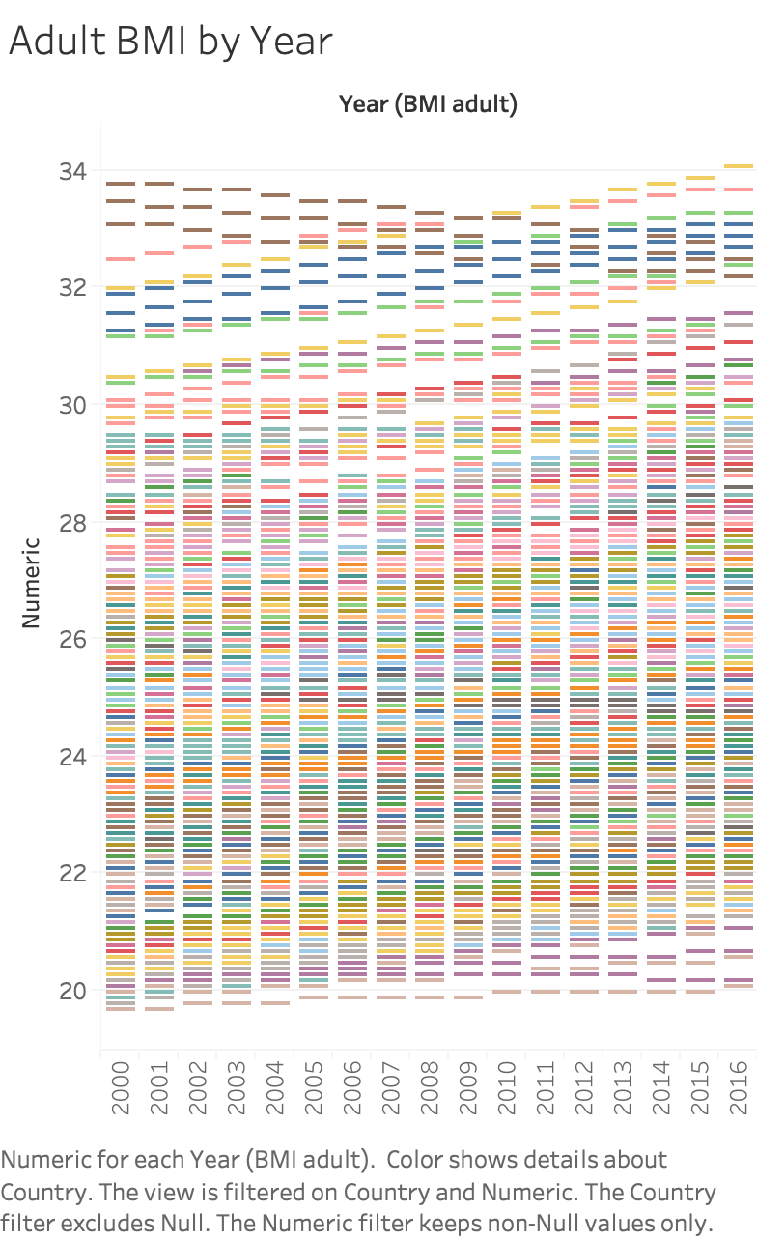

This graph shows each country over a 16 year period and how their BMI increases or decreases.

A similar graph shows much the same thing and has a trend line in addition to see the correlation of the data.

I used a geographic type graph to show income levels and health expenditure per country

I also looked at BMI by gender

# Conclusions

From the data and graphs we are able to reach the conclusions to the answers that we asked and more. The question were:

1. Are countries with high income more healthy than those with low income?
2. Are countries with high health expenditure healthier than those with low health expenditure?
3. Are countries with high income and high health expenditure are healthier than those with low income and low health expenditure?

The answer to these questions:

1. According to all the data countries with high income are not more healthy than those with low income. In fact, they are significantly more obese than countries with low income.
2. Countries with a high health expenditure are not healthier than those with a lower expenditure.
3. The short answer to this is yea and no. High income countries that spend a lot on health expenditure are more obese, but they also live longer because that have the income to make it so. Compare that with a low income country who cant afford health costs, they may not live as long but they are not as obese.

We can make some inference from the data to. Based on the trend lines it is safe to say that there is an obesity epidemic and something needs to be changed. Obviously having more health coverage or gym memberships are not doing anything. We could probably globally standardize health costs and still be where we are obesity-wise, but everyone would be able to have health insurance, etc. We can also infer that in high income countries, their higher obesity rates are largely due to a sedentary lifestyle and being able to buy as much of any food you could want.

# Further study

Of course further study is needed to get a better picture. The direction to go after this would be to find out what can be done about this obesity so that in the coming years that trend will start declining as opposed to increasing. Global obesity awareness, meaning that with a little more education about obesity people may start to take care of themselves better.

# Works Cited

Adult Obesity Facts | Overweight & Obesity | CDC. (n.d.). Retrieved from https://www.cdc.gov/obesity/data/adult.html

(n.d.). Retrieved from http://apps.who.int/nha/database/Select/Indicators/en

GBD 2015 Obesity Collaborators, Afshin, A., Forouzanfar, M. H., Reitsma, M. B., Sur, P., Estep, K., . . . Murray, C. J. (n.d.). Health Effects of Overweight and Obesity in 195 Countries over 25 Years. Retrieved from https://www.ncbi.nlm.nih.gov/pmc/articles/PMC5477817/

Overweight and obesity. (2018, December 27). Retrieved from https://www.who.int/gho/ncd/risk_factors/overweight/en/